Homework 7

|  |  |
| --- | --- |
| **Meta information** | |
| Name | Savan Kiran |
| Program | Masters in Computer Science |
| Questions skipped | PART D, PART C |
| Questions substituted | N/A |
| Extra credit questions | N/A |

# PART A

1. The white patch in the Macbeth image is in the bottom left corner. We ignore the edges of the patch as they are unreliable and pick the top-left (start) pixel of the rectangle as (100,325) and bottom-right (end) pixel as (150,380). We calculate the average values of R, G and B for all the pixels inside the rectangle and then scale the result so that the max is 250. This gives us an estimate of the illuminant color of the light.

Below is the code snippet to calculate the average R,G,B for the white patch.



Figure 1 shows the start and end pixels of the white patch in the Macbeth image.

Illuminant color estimated for Macbeth image with ‘sy1-50MR16Q’ light is,

Illuminant color est for light -> syl-50MR16Q

237.7861 220.3899 250.0000

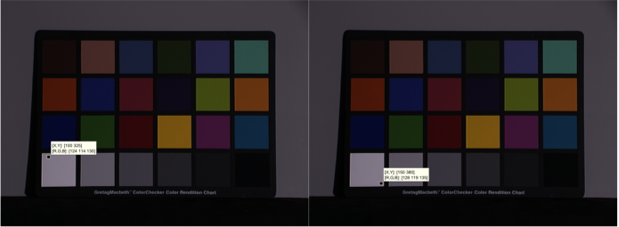

Figure 1. The start and end pixel of the white patch in Macbeth image.

1. Using the same process as explained in step 1, we get the Illuminant color estimated for Macbeth image with ‘solux-4100’ light as,

Illuminant color est for light -> solux-4100

132.1031 158.8935 250.0000

1. We calculate the angular error between the two illuminant colors in degrees by finding the dot product of both the color vectors divided by their magnitudes and using it as input in acosd() matlab function.

Below is the code snippet that calculates angular error.



The angular error between ‘sy1-50MR16Q’ and ‘solux-4100’ is found to be,

Angular error between two light colors found above:

13.8441

1. The diagonal model for the illuminant colors and image color is given by,

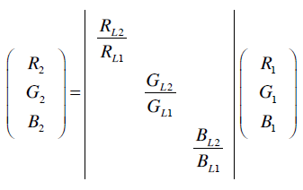

Using the diagonal model with illuminant colors found earlier and the bluish image, we find the one under the canonical light. We remove the brightness factor from all 3 images – canonical, original and the corrected, by scaling up the images so that the max value in any channel is 250.

Below is the code snippet for the same,





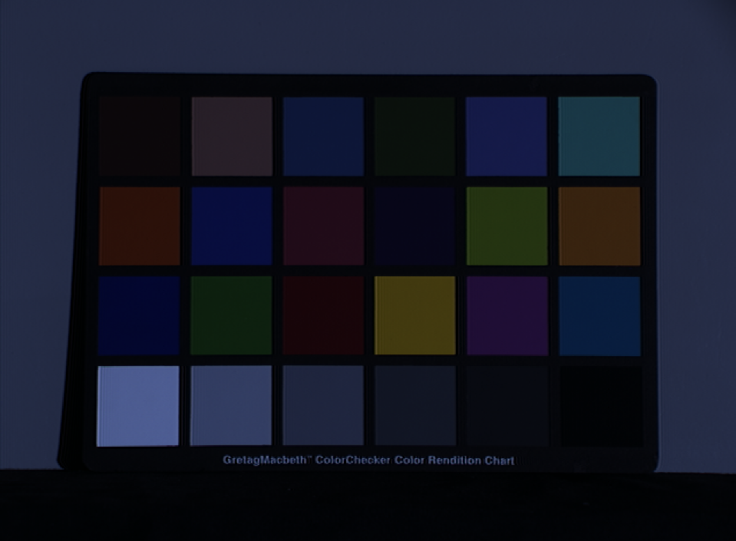

Figure 2. Macbeth bluish image

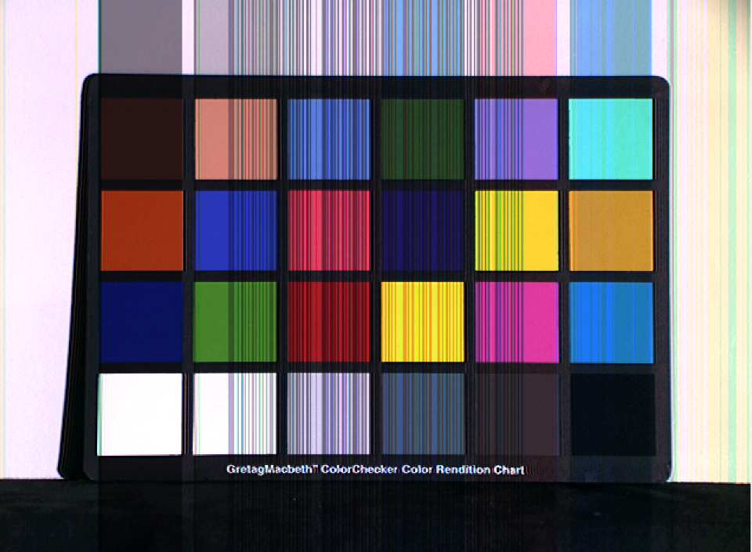

Figure 3. Macbeth canonical image

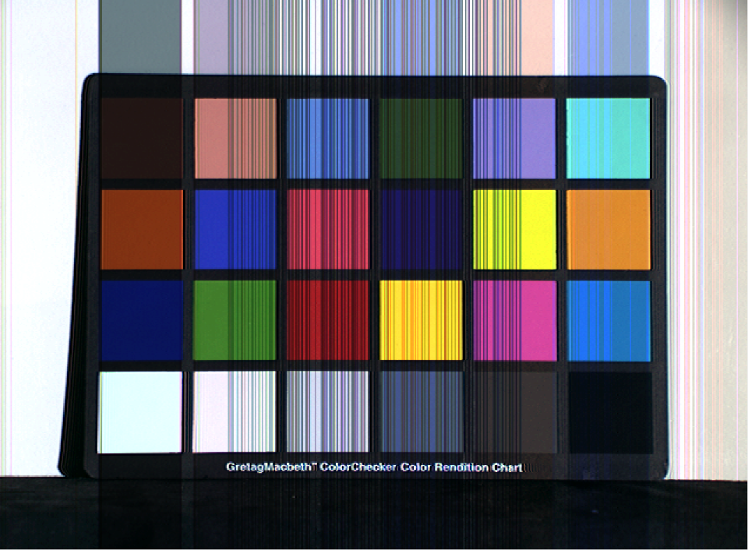

Figure 4. Macbeth corrected image

The figures 2, 3 & 4 show us the bluish, canonical and the correct image.

1. We now calculate the RMS error in (r,g) between
   1. The original image and the canonical image

RMS error(r,g) b/w original & canonical image: 0.25364

* 1. The improved corrected image and the canonical image

RMS error(r,g) b/w corrected & canonical image: 1.1819

The code snippet to calculate RMS error is given by,



1. We will now use the MaxRGB method to estimate light color for apples, ball and blocks.

Below is the code snippet for MaxRGB algorithm.



We also calculate the angular errors between the 3 estimates. The angular errors were as follows,

Angular error for apple: 10.348

Angular error for ball: 19.3247

Angular error for blocks: 7.897

The code snippet for the same is below,



We also estimate the illuminant color for solus-4100 light on Macbeth image as,

Macbeth solus-4100 light Max RGB est. light:

109 121 176

1. We now calculate the corrected image for all 3, apples, ball and blocks, using the MaxRGB illumination found in previous step.

Below is the code snippet for the same.







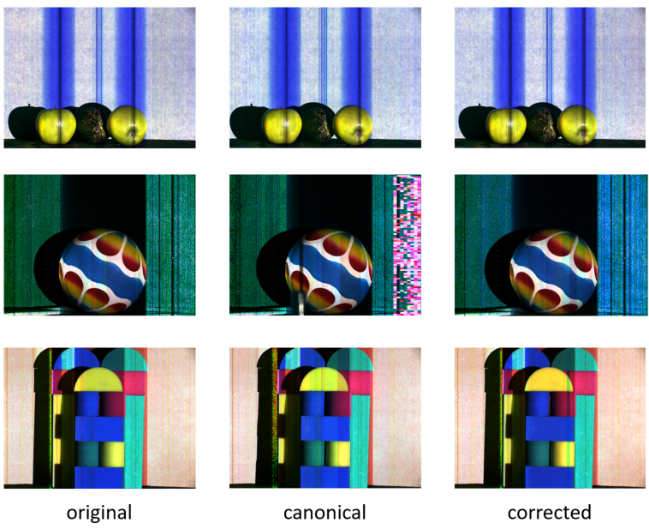

Figure 5. The original and canonical images for apple, ball and blocks are shown in first two columns. The third column is the image corrected using MaxRGB illumination estimate

The angular error for the mapped images is given below.

Angular error for apple: 10.348

Angular error for ball: 19.3247

Angular error for blocks: 7.897

The (r,g) RMS error for the mapped images is given below.

RMS error(r,g) b/n canonical and original image apple: 0.18592

RMS error(r,g) b/n canonical and corrected image apple: 1.635

RMS error(r,g) b/n canonical and original image ball: 0.35792

RMS error(r,g) b/n canonical and corrected image ball: 0.99758

RMS error(r,g) b/n canonical and original image blocks: 0.34908

RMS error(r,g) b/n canonical and corrected image blocks: 0.96665

There is a good agreement between RMS (r,g) error (b/n canonical & original) and angular error for apple and ball. But it is a bit odd for blocks where it has low angular error but high RMS error.

1. We would now compute angular and RMS (r,g) error for gray-world illumination estimates. The code is similar as last step, except we now introduce gray-world estimation,



The angular error for the gray-world is given below.

Angular error for apple: 9.952

Angular error for ball: 13.6535

Angular error for blocks: 13.8635

The (r,g) RMS error for the gray-world is given below.

RMS error(r,g) b/n canonical and original image apple: 0.18592

RMS error(r,g) b/n canonical and corrected image apple: 1.6322

RMS error(r,g) b/n canonical and original image ball: 0.35792

RMS error(r,g) b/n canonical and corrected image ball: 0.99297

RMS error(r,g) b/n canonical and original image blocks: 0.34908

RMS error(r,g) b/n canonical and corrected image blocks: 0.96836

From the RMS (r,g) errors, we can observe that gray-world has lower error for apple and ball, but slightly higher for blocks. Thus, we can conclude that the gray-world works better for this data.

# PART B

1. From the diagonal model we know that the diagonal matrix is composed of ratio of the illumination lights in each channel.



However, from above equation, we can see that the ratio of lights in each channel is equivalent to ratio of pixels in images for corresponding channel. Since we know the RGB composition of both the images, we can calculate the diagonal matrix. We will consider that minimum sum of the squared errors is our definition of best. Now, to have overall sum of squared errors to be minimum across all pixels for each channel, we can pick median of ratio of colors as the diagonal matrix elements. However, taking the median (or mean) of the ratios as diagonal matrix elements is only an approximation and hence cannot guarantee a better answer using (r,g) measure. Below is the code snippet that shows the calculations for the same.



1. We now calculate the corrected image for all 3, apples, ball and blocks, using the best diagonal map we derived in previous step. Figure 6 shows the same.

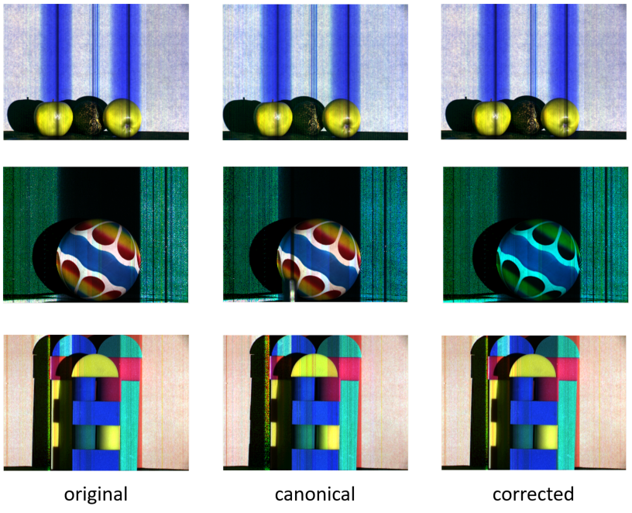

Figure 6. The original and canonical images for apple, ball and blocks are shown in first two columns. The third column is the image corrected using best diagonal map derived earlier

RMS error (r,g) is found to be,

[Best] RMS error(r,g) for apple: 1.6356

[Best] RMS error(r,g) for ball: 1.0465

[Best] RMS error(r,g) for blocks: 0.96377

Which is very much comparable to previous two methods (maxRGB and gray-world). The error however increases in case of the ball which is also evident in Figure 6 where corrected ball image is a lot bluer than it should have been.